Jennifer Daniel

CIT480

Chapter 16 Exercises

**Exercise 16-1:**

Part 1/2:

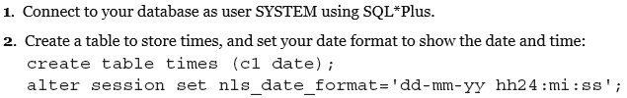

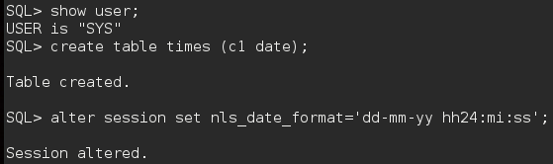

Part 3:

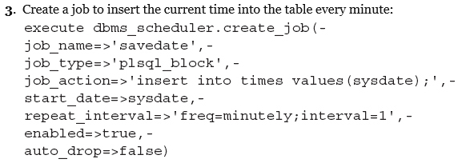

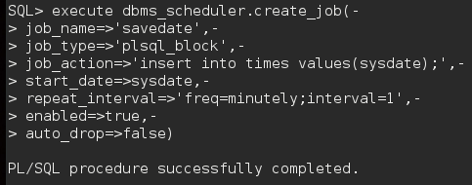

Part 4:

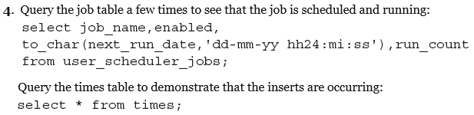

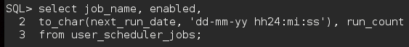





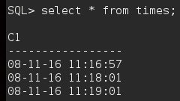

Part 5:





Part 6:



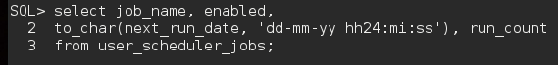



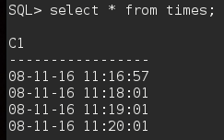

Part 7:





**Exercise 16-2:**

Part 1/2:

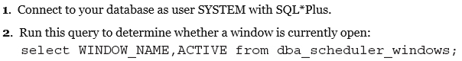





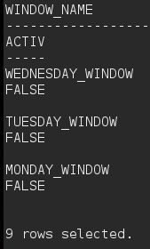

**# All inactive**

Part 3:



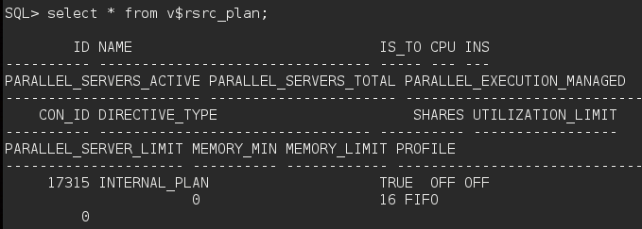

Part 4:





Part 5:

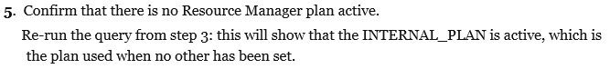



Part 6:

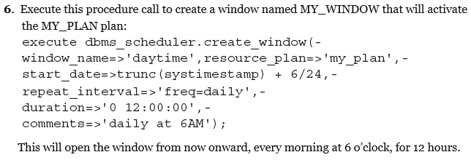

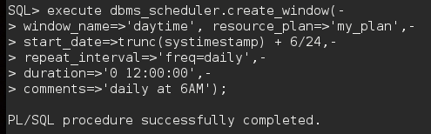

Part 7:

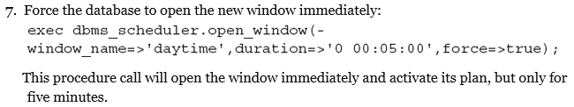

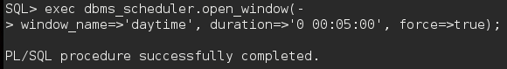

Part 8:



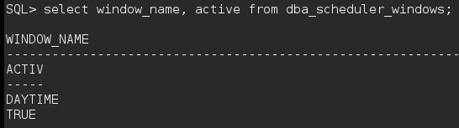

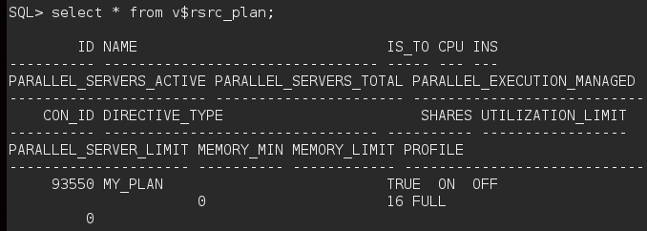

Part 9:



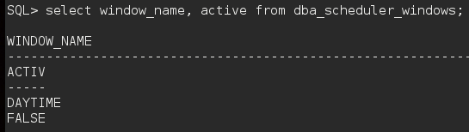

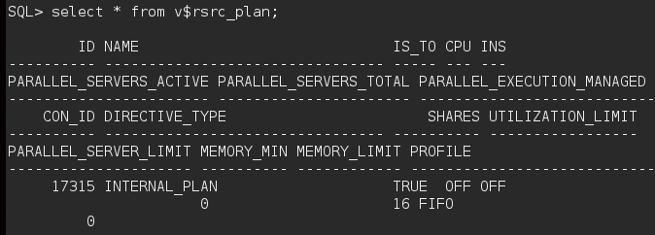

Part 10:



